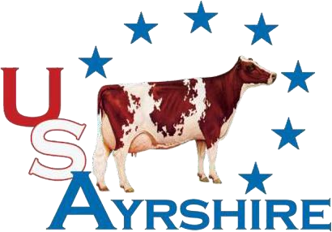
Ayrshire Breeders’ Association
PO Box 826 Brattleboro, VT 05302-0826
Phone: (800)952-5200 ext 4085 • Fax: (802)254-8251
E-mail: info@usayrshire.com • Web: www.usayrshire.com

Ayrshire Breeders’ Association Youth Lease Agreement

Lease Program
The Junior leasing program is designed to encourage young people to become members and to get involved in a dairy project and learn about animal care and responsibility.

Animal

Name:

Registration

Number

Date

of

Birth

Youth

Lessee

Date

of

Birth

Address

City

State

Zip

Phone

Number

Email

Recorded Owner of Animal
Address

Effective Date (Must be prior to August 1)

We, the undersigned have read, understand, and agree to comply with the objectives, rules and terms of the Ayrshire Breeders’ Association Youth Lease Agreement. We agree to hold harmless the Ayrshire Breeders’ Association, its employees, members and agents from any and all liability regarding this lease, lease program or leased animal.

Recorded Owner Date
Youth Lessee Date

Parent/Guardian Date

Approved:

Operations Manager, Ayrshire Breeders’ Association Date

Ayrshire Breeders’ Association
Youth Lease Agreement Rules

.
- All Jr exhibitors exhibiting a leased animal at National Shows must have an
Ayrshire Breeders Association lease on file by August 1st of the year they are
exhibiting the animal.

- If the Jr. becomes the owner of the leased animal anytime during the year
exhibiting, all lease agreements will be terminated. The Junior member must
notify the national office and the registration transfer terminates all leases.

- A maximum of two registered Ayrshires may be leased by any youth at one
time. Animals may be leased by individuals only.

- The lease may be terminated by either the owner (lessor) or the youth (lessee)
by providing written notice to the other party and then notifying the National
Office.

- The leasing Junior is the only person allowed to exhibit the animal as a Jr. at
National Junior Shows, no alternate leadspersons may be used. The owner may
exhibit the animal in a separate open show.

