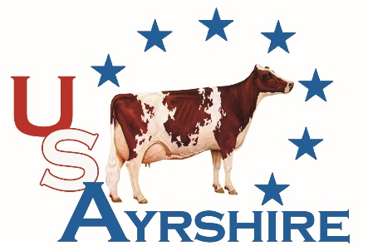
REWARDS
Benefits
- Completed lactations added to animal’s record
- Eligible for ABA Production Awards
- Free online pedigrees
- Includes Classification
  - Only females included
- Includes registration of animals born during enrollment year
  - Up to 65% of the # of animal enrolled
  - Animals over 65% charged $14 per animal registered at < 4 month of age
  - Registrations over 4 months charged $16 per animal
- Discount on transfer fees

Fees
Herd Fee | $100
Cost per cow | $25
- 5% discount for applications received by October 31, 2025
- 5% discount for 51 -100 animals enrolled
- 10% discount for 101-200 animals enrolled
- 15% discount for 201+ cows enrolled

Additional Information
- REWARDS is an annual enrollment period starting January 1st each year
- You can enroll anytime, herds enrolled after January 1st will not receive REWARDS benefits on work already processed

*The Blue Book and online Ayrshire Digest will be included as available.
REWARDS Program Application

Name________________________________________________________________
Address______________________________________________________________
Telephone_______________________ Email________________________________
Account # ___________________ DHI Herd Code________________________
Associated Accounts____________________________________________________
_____________________________________________________________________
_____ Enclosed is a copy of my latest DHI test sheet
_____ # Cows to enroll (includes milking and dry cows)

Fees
Herd Fee: $ _ 100
Animal Fees (# cows X $25) $_______
5% discount if enrolling prior to 10/31 $_______
Volume discount $_______
(5% for 51-100 cows, 10% for 101-200 cows, 15% for 200+ cows)

I prefer the following payment option:
_____ Check Enclosed
_____ Credit Card
#__________________________________ EXP. Date__________ CCV________
Sgniature____________________________________________________________
